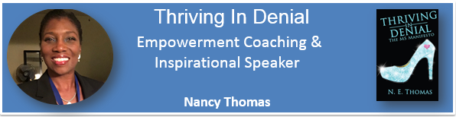

EMPOWERMENT COACHING is the authentic and transformative blending of
Leadership, Mentorship & Coaching designed to ignite in YOU the power of
‘Comfort in your discomfort’ in order to achieve what you really want.

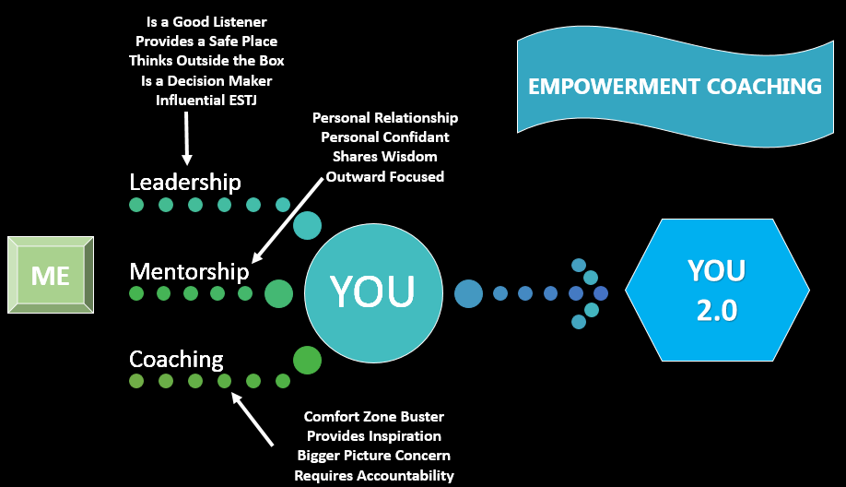
Nancy is a multidimensional and dynamic personality. Early in her life, her father told her she was a “star shaped peg and star shaped pegs don’t fit into square shaped holes”! From there she was free to follow her passions in her own unique way. To that end, Nancy has learned to take what life offers and make opportunities to grow in ways that most simply dream about. Authentic empowerment allows you to…
- Receive a full ride college scholarship to run NCAA Div-1 Track & Field and turn that into a leadership training ground becoming a leader of several organizations, chosen as a Drake Mover & Shaker, and emerging as Women’s Team Captain
- Travel in Europe and work in Japan and turn that into a real life learning opportunity absorbing many other cultures and developing authentic appreciation for living in the U.S.A.
- Earn a law degree, choose not to follow the traditional legal path and then create your own successful career path in international business and commercial transactions
- Receive a diagnosis of Multiple Sclerosis in June 2003 followed by an MS induced stroke that left her with left side paralysis in July 2004. She chose not to follow doctor’s orders and turned that medical catastrophe into the motivation to rebuild her body & spirit. She’s now training for the 2018 World Club & Crew Dragon Boat Championships in Szeged, Hungary. Now, black girls paddle!
- Receive a job offer in 2015 moving her family to Portland, OR but was down sized just six months later. Then turn that situation into an opportunity to take her legal skills in a new direction. Now she’s a senior internal auditor and will soon be pursuing her Certified Internal Auditor accreditation in 2018.

What makes a person influential? Wise? Inspirational? Humble? Life experiences! NOTHING humbles, teaches and inspires like life and professional circumstances coming at you fast. This is the essence of Thriving in Denial EMPOWERMENT COACHING.
Contact Nancy today at thrivingindenial@gmail.com.

